**Addressing Sepsis Readmission Rates at NYC Health + Hospitals/Elmhurst: A Quality Improvement Perspective**

**Introduction**

NYC Health + Hospitals/Elmhurst is a 545-bed Level 1 Trauma and Academic Medical Center located in Queens, serving a diverse population of over 160,000 residents. Known for its commitment to delivering high-quality care, Elmhurst plays a critical role in addressing the healthcare challenges faced by its underserved community. With over a million patient visits annually, the hospital provides essential services to a multicultural demographic, including a significant number of patients who rely on Medicaid and other public assistance programs.

One of the hospital’s key challenges is reducing the 30-day readmission rate for sepsis patients, a crucial measure of care quality and patient outcomes. Sepsis, a life-threatening condition caused by a dysregulated response to infection, remains a major cause of morbidity and mortality. To tackle this issue, the Quality Management team has launched a focused effort to identify and address the factors driving these readmissions.

**Understanding Sepsis Readmission Within 30 Days**

Sepsis readmission within 30 days of discharge refers to patients who are hospitalized again for sepsis or related complications shortly after their initial discharge. This metric is a vital indicator of the effectiveness of hospital discharge planning, post-discharge follow-up, and outpatient management. Patients at risk of such readmissions often have chronic health conditions, limited social support, or face barriers to accessing timely follow-up care.

At Elmhurst, sepsis readmissions disproportionately affect Medicaid beneficiaries, particularly within the Hispanic community. These patients often encounter significant socioeconomic and healthcare access challenges, underscoring the need for interventions that address both clinical and social determinants of health.

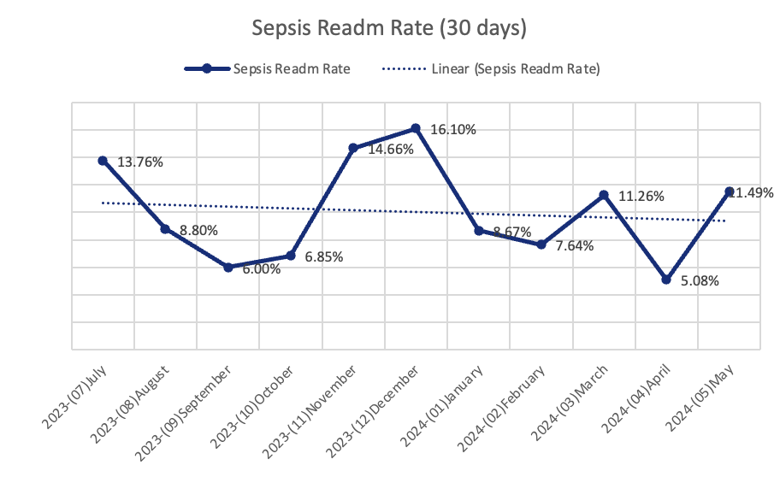

**The Importance of Reducing Sepsis Readmissions**

Sepsis readmissions lead to increased risks for patients, including prolonged recovery, reduced quality of life, and heightened vulnerability to further complications. For hospitals, these readmissions place a strain on resources and may result in financial penalties under value-based care programs. At Elmhurst, the current sepsis readmission rate of 9.8% (July 2023 to May 2024) highlights the need for targeted strategies to improve patient outcomes and reduce healthcare costs.

**Investigating the Root Causes**

In June 2024, the Quality Management team conducted a detailed investigation within the Medical Intensive Care Unit (MICU). Through one-on-one meetings with doctors, nurses, and allied health workers, the team identified gaps in discharge planning, inconsistencies in post-discharge follow-up, and variability in patient adherence to treatment plans.

Data analysis provided additional insights into trends among readmitted patients:

* **Health Conditions:** Sepsis and related infections were most prevalent, particularly in patients aged 10 to 20 years. Other conditions, such as respiratory and renal disorders, also contributed significantly to readmissions.
* **Social Determinants:** The majority of readmitted patients were Medicaid recipients (76 out of 146 cases), with Hispanic patients accounting for 70 cases. This data emphasized the importance of culturally sensitive interventions and enhanced support systems.

**Interventions and Process Measures**

The team implemented a comprehensive approach to address sepsis readmissions:

1. **Enhanced Discharge Planning:** Standardized protocols were introduced to provide clear, comprehensive education on managing sepsis and adhering to prescribed medications. Discharge summaries now include explicit instructions and warning signs that require immediate attention.
2. **Post-Discharge Follow-Up:** Efforts were made to ensure patients scheduled follow-up appointments within seven days of discharge. To improve adherence, the hospital streamlined scheduling processes and emphasized the importance of follow-ups during discharge consultations.
3. **Community Engagement:** Targeted outreach programs were launched to connect Hispanic patients with culturally competent care navigators. These navigators assist with scheduling appointments, overcoming language barriers, and addressing social challenges. Additionally, patient education materials were simplified and made accessible to support patients and their families.

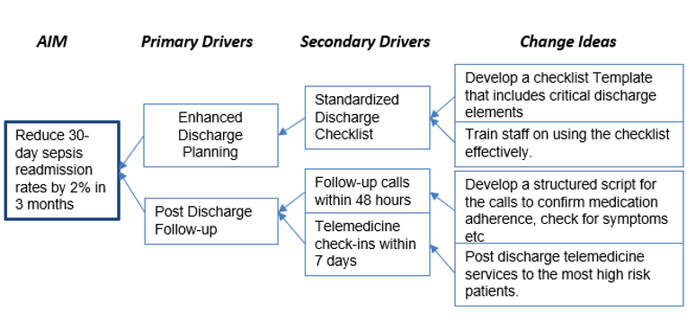

**Balancing Measures and Challenges**

To assess the effectiveness of these interventions, the team tracked follow-up appointment attendance as a balancing measure. Early results showed a modest improvement, with 68% of patients attending their scheduled visits, up from 57%. However, several challenges persist:

* **Resource Constraints:** Limited staffing and high patient volumes continue to hinder the delivery of personalized follow-up care.
* **Patient Barriers:** Socioeconomic factors, including transportation difficulties and work commitments, remain significant obstacles to appointment adherence.
* **Data Limitations:** Inconsistent documentation in electronic health records complicates the tracking and evaluation of interventions.

**Conclusion**

Reducing sepsis readmissions requires a holistic approach that addresses clinical, social, and systemic factors. At Elmhurst, the emphasis on equity and community-focused care has been instrumental in driving improvements. By enhancing discharge planning, strengthening follow-up processes, and engaging underserved populations, the hospital aims to achieve sustainable reductions in sepsis readmissions.

Looking ahead, Elmhurst plans to expand its quality improvement initiatives by integrating advanced analytics and patient-centered technologies. These efforts will ensure the hospital continues to provide outstanding care while addressing the unique needs of its diverse community.